
FACULTY OF ENGINEERING AND TECHNOLOGY

A REPORT ABOUT THE HIGH-LEVEL BACKEND DESIGN FOR NUMERICAL AND DIFFERENTIAL PROBLEM-SOLVING USING OBJECT ORIENTED PROGRAMMING

COURSE UNIT: COMPUTER PROGRAMMING

LECTURER: Mr. MASERUKA BENEDICTO

SUBMITTED BY: GROUP 16
E-MAIL: matlabgroup16@gmail.com

Submitted in partial fulfillment of the requirements of COMPUTER PROGRAMMING

DATE OF SUBMISSION.............../............../..............
SUBMITTED TO: .......................................................

DECLARATION
We, the undersigned members of group 16, do hereby declare that this report is the result of our own work carried out in partial fulfillment of the requirements of this course.
NAME SIGNATURE
KABWERU ANDREW .............................
CHEMONGES MIKIRAR ........ .....................
NAGASHA RITTA ............ ..................
DIKITAL JOHN ............. .................
SANYU JOY ...............................
OULE SADOCK ............. ..................
WANGUSI DAVID .............. ..................
SEBATIKA COLLINE ................................
ATYANG MILDRED ................................
KITUTU LEONARD .................................

APPROVAL
This report has been submitted and prepared by group 16 as part of the requirements for the completion of module 1to 5 under the guidance of our lecturer
Mr Maseruka Bendicto
Computer programming lecturer
Name: ......................................
Signature: ..................................

ACKNOWLEDGEMENT
We wish to express our sincere gratitude to our lecturer for the valuable guidance, encouragement and constructive criticism provided throughout the project. We extend our thanks to the fellow members of group 16 and friends for their constant support, discussions and suggestions during the development and testing of Matlab codes.
Finally, we give special thanks to our families for their patience, understanding and continuous encouragement throughout the course of this study

DEDICATION
This report is dedicated to our beloved families whose support, love, and encouragement have been the foundation of our academic achievements. We continue to dedicate this work to all students and researchers passionate about the application of computational and numerical methods in solving real world engineering and scientific problems.

ABSTRACT
This project presents an object-oriented programming approach to implementing numerical methods in Matlab. The main objective was to design a modular, reusable and extensible system that applies the OOP principles of abstraction, encapsulation, inheritance and polymorphism to solve both algebraic and differential computational problems.
An abstract parent class was created to define the structure for all numerical methods, with two subclasses.
Each subclass redefines the abstract solve method, showcasing polymorphism and ensuring method specific computation.

LIST OF ACRONYMS/ ABBREVIATIONS
- MATLAB – Matrix Laboratory
- abs - absolute

Table of Contents
DECLARATION i
APPROVAL ii
ACKNOWLEDGEMENT iii
DEDICATION iv
ABSTRACT v
LIST OF ACRONYMS/ ABBREVIATIONS vi
CHAPTER ONE: INTRODUCTION 1
1.1 Background. 1
1.2 Historical Development 1
CHAPTER TWO: QUESTION ONE 2
2.1 Introduction 2
2.2 SUPER CLASS CODE 2
2.2.1: steps taken to write the code 2
2.3 SECTION 1: DIFFERENTIAL PROBLEMS 3
2.3.1 introduction 3
2.3.2 steps taken in writing the code 4
2.4 SECTION 2: INTEGRATION PROBLEMS 6
2.4.1 introduction 6
2.3.2 steps taken in writing the code 6
SECTION THREE: TEST SCRIPT 8
CHAPTER THREE: CONCLUSION AND RECOMMENDATION 10
3.1 CONCLUSION 10
3.2 RECOMMENDATIONS 10
CHAPTER FOUR: REFERENCES 11
APPENDICES 12

CHAPTER ONE: INTRODUCTION

1.1 Background.
MATLAB, which stands for matrix laboratory, is a high-performance programming language and environment designed primarily for technical computing. Its origins trace back to the late 1970s when Cleve Moler, a professor of computer science, developed it to provide his students with easy access to mathematical software libraries without requiring them to learn Fortran.

1.2 Historical Development
  - Initial Development: The first version of MATLAB was created in Fortran in the late 1970s as a simple interactive matrix calculator. This early iteration included basic matrix operations and was built on top of two significant mathematical libraries: LINPACK and EISPACK, which were developed for numerical linear algebra and eigenvalue problems, respectively.
  - Commercial Launch: MATLAB was officially launched as a commercial product in 1984 by MathWorks, a company founded by Moler along with Jack Little and Steve Bangert. This marked the transition from a simple calculator to a comprehensive programming environment. The software was reimplemented in C, enhancing its capabilities with the addition of user-defined functions, toolboxes, and graphical interfaces.
  - Expansion and Toolboxes: Over the years, MATLAB has expanded significantly. By the late 1980s, it had introduced several specialized toolboxes for various applications, including control systems and signal processing. The introduction of the Simulink environment further allowed users to model and simulate dynamic systems graphically.
  - Modern Enhancements: Recent versions of MATLAB have introduced features like the Live Editor, which allows users to create interactive documents that combine code, output, and formatted text. This evolution reflects MATLAB's ongoing adaptation to meet the needs of its diverse user base across academia and industry.

CHAPTER TWO: QUESTION ONE

2.1 Introduction
We were required to implement the concepts of classes, encapsulation, inheritance, polymorphism and abstraction.
To develop and test a high-end backend implementation of a numerical methods application for solving computational problems. While ensuring that the parent class holds all abstract methods with two subclasses, one for differential problems and the other for numerical problems.

2.2 SUPER CLASS CODE

2.2.1: steps taken to write the code
Step 1: defining and describing the class.
We started by defining the Matlab class as NumericalMethods which is the abstract super class for all numerical methods
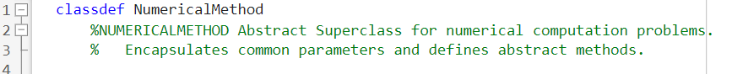
Step 2: variables stored in the class
We listed the class properties as shown below and declared them with access protected so that only the class and its sub classes can access these values
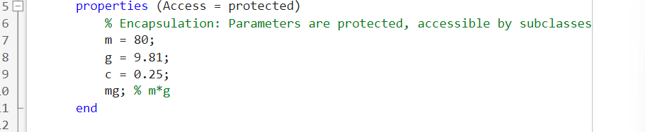
Step 3: methods
We designed the class as an abstract superclass that defines a common structure for all computation problems
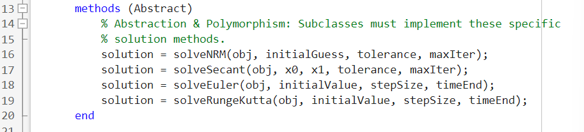
(i). Constructor
This was to initialise the property mg and ensuring that all subclasses start with the correct initialised constants
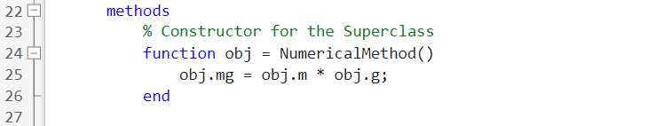
(ii). Common function
This was to provide a common operation shared by all subclasses and compute the net force on an object under the influence of drag and gravity
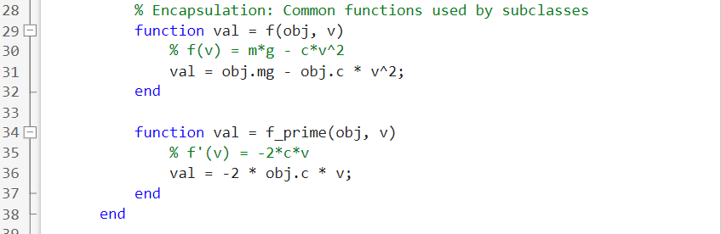
(iii). Static function
This was to define a differential equation for use in integral methods i.e. Euler and Runge Kutta
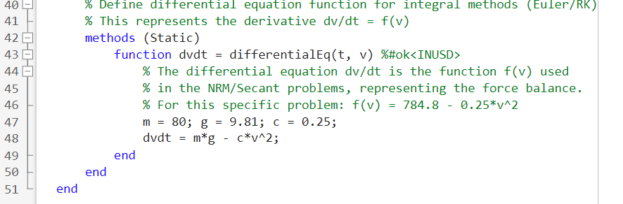

2.3 SECTION 1: DIFFERENTIAL PROBLEMS

2.3.1 introduction
implement the concepts of classes, encapsulation, inheritance, polymorphism and abstraction.
To develop and test a high-end backend implementation of a numerical methods application for solving numerical method problems.

2.3.2 steps taken in writing the code
Step 1: defining the sub class
We defined the subclass as DifferentialProblems that inherits from the parent class NumericalMethods
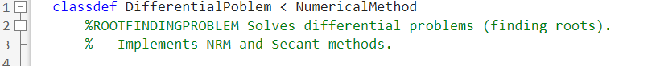
- implementation of newton Raphson method
step 1: function definition and initialisation
we defined the function as solveNRM and set x as the starting value, made it run up to maxIter times and calculate fx and fpx
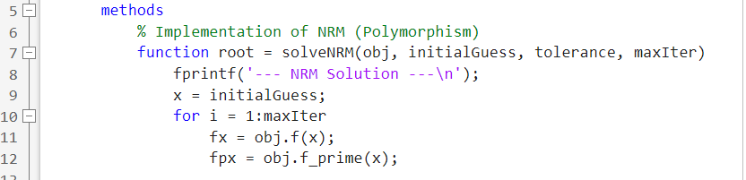

Step 2: checking for convergence and zero derivative
We set to print the root as x when abs(fx) is less than tolerance and display ‘Zero derivative encountered.’ NRM failed. When the derivative is not given
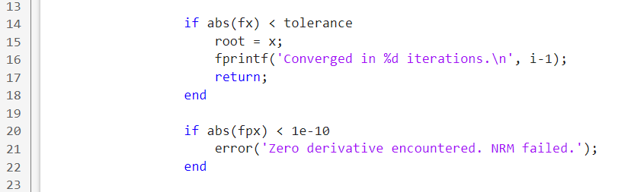

Step 3: updating x and printing of root
We set it to update x to the next value of x and also print the root when maximum iterations are reached
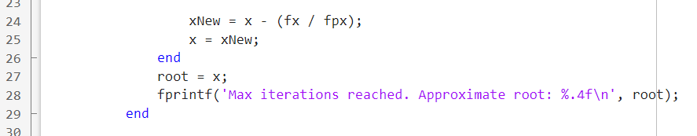

- implementation of secant method
step 1: function definition and initialisation
we defined the function as solveSecant and set x as the starting value, made it run up to maxIter times and calculate fx0 and fx1
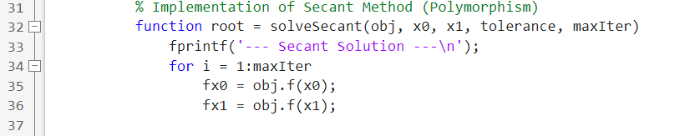

Step 2: checking for convergence and zero derivative
We set to print the root as x when abs(fx1) is less than tolerance and display 'Secant method failed: zero denominator.’ When abs(fx1-fx0) is less than 1e-10
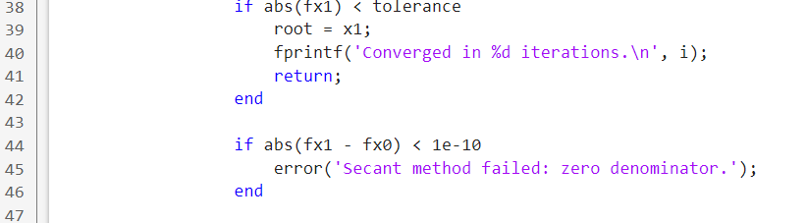

Step 3: updating x and printing of root
We set it to update x to the next value of x and also print the root when maximum iterations are reached
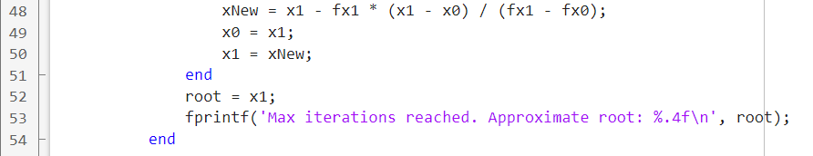

Dumpy function
We wrote this code to output an error in case the problem provided cannot be implemented by the both secant and NRM i.e. Euler and Runge Kutta problems provided
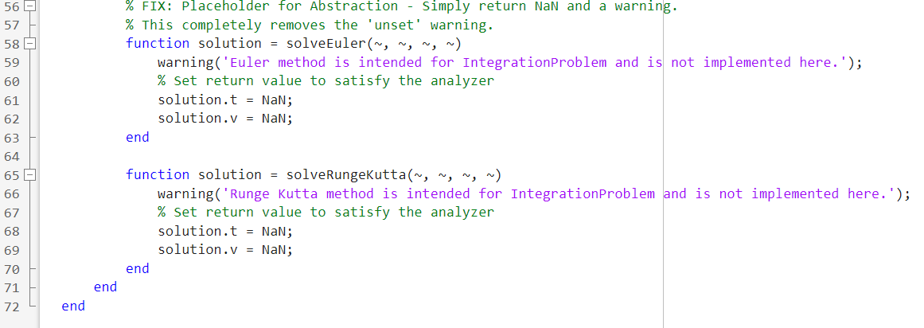

2.4 SECTION 2: INTEGRATION PROBLEMS

2.4.1 introduction
implement the concepts of classes, encapsulation, inheritance, polymorphism and abstraction.
To develop and test a high-end backend implementation of a numerical methods application for solving integration problems.

2.3.2 steps taken in writing the code
Step 1: defining the sub class
We defined the subclass as IntegrationProblems that inherits from the parent class NumericalMethods
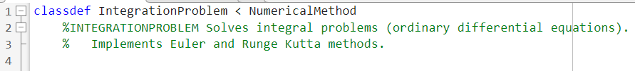

step 2: Dumpy function
We wrote this code to output an error in case the problem provided cannot be implemented by the both secant and NRM i.e. Euler and Runge Kutta problems provided
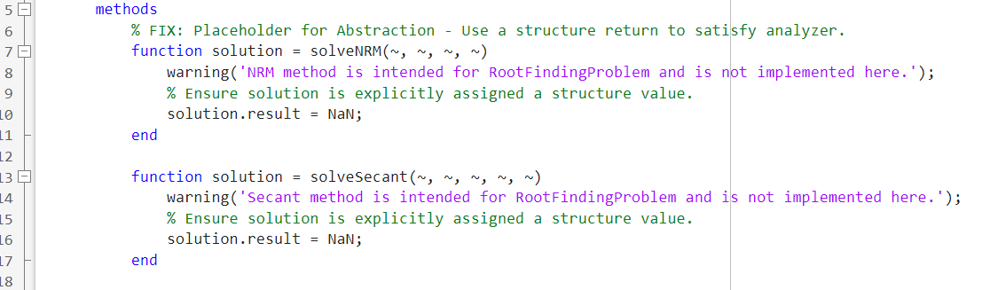

- implementation of Euler method
step 1: defining the function and its initialisation
we defined the function as solveEuler and set v1 as the starting value, made it run up to timeEnd times and calculate v(i+1)
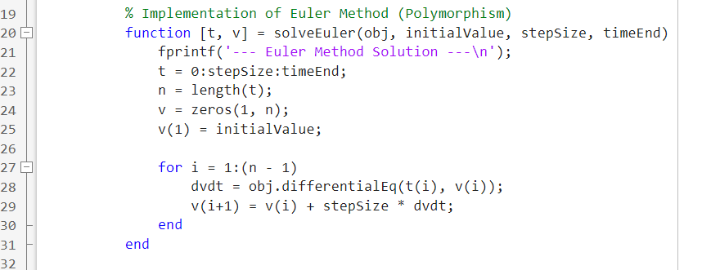

- implementation of Runge Kutta
step 1: defining the function and its initialisation
we defined the function as solveRungeKutta and set v1 as the starting value, made it run up to timeEnd times and calculate k1, k2, k3, k4, and then v(i+1)
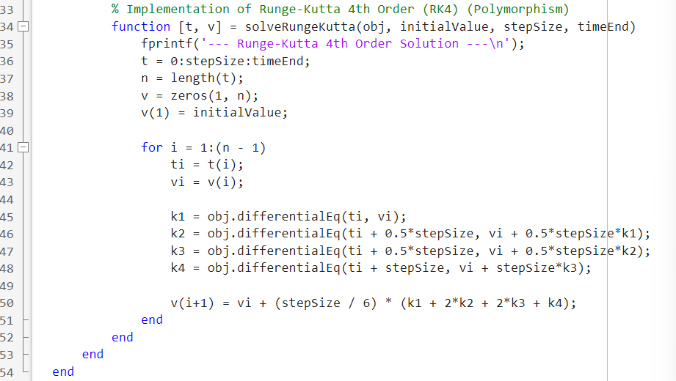

SECTION THREE: TEST SCRIPT
The script begins by testing the DifferentialProblem subclass for root-finding problems using the Newton-Raphson and Secant methods. These functions determine the velocity at which the net force acting on a falling object equals zero, representing the terminal velocity.
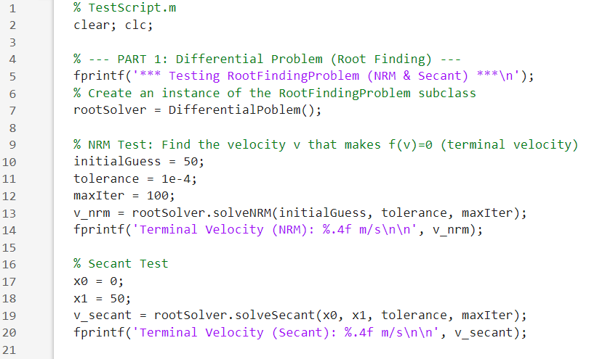
In the second part, the IntegrationProblem subclass is tested for solving an ordinary differential equation representing motion under gravity and air resistance. Both Euler’s Method and the Runge-Kutta 4th Order Method (RK4) are applied to compute velocity over time.
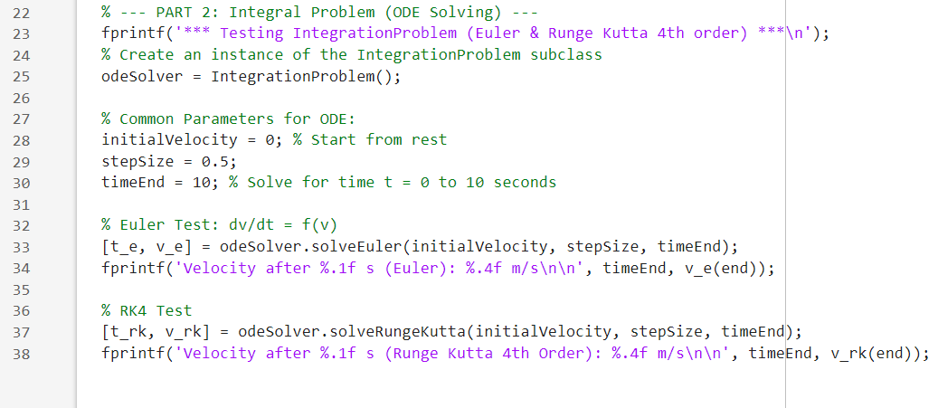
OUTPUT
The results are displayed in the MATLAB Command Window, showing convergence values and computed velocities. These tests verify that the designed OOP framework correctly encapsulates numerical methods within an extendable and maintainable structure.
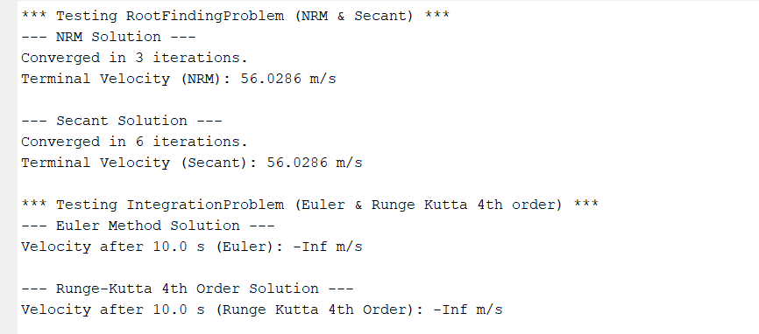

CHAPTER THREE: CONCLUSION AND RECOMMENDATION

3.1 CONCLUSION
This project successfully demonstrated the application of object-oriented programming (OOP) principles—abstraction, encapsulation, inheritance, and polymorphism—in implementing numerical methods using MATLAB.
By structuring the program into a parent abstract class and two subclasses, the design achieved modularity, code reusability, and clarity in handling different computational problems.

3.2 RECOMMENDATIONS
- Future work can include additional numerical methods such as Bisection, Gauss-Seidel, Adams-Bashforth, or Finite Difference methods within the same OOP framework.
- A MATLAB GUI can be developed to make the application user-friendly, allowing users to select methods, input functions, and view graphical results interactively.
- Future implementations may incorporate vectorization and parallel computing to improve computational efficiency, especially for large datasets or complex simulations.
- Introduce automatic error estimation and comparison with analytical or exact solutions to enhance result validation and learning outcomes.
- The developed framework can be adapted for teaching numerical methods, allowing students to visualize algorithm behaviour and understand OOP concepts in a practical setting.

CHAPTER FOUR: REFERENCES
- course Lecture notes (module 1 – 5)
- Matlab documentation

APPENDICES


